Report on Water Availability and Management at Ichalkaranji Water Treatment Plant
Introduction
During our visit to the water treatment plant located in Ichalkaranji, we gathered critical insights into the existing water management system. One of the key findings was the disparity between the available water quantity and the daily consumption rate. This gap highlights the urgent need for efficient water utilization strategies to ensure sustainable supply and prevent shortages in the near future.
Analysis of Reservoir Storage Trends
From the data collected between January 2023 and March 2025, we observed significant seasonal variations in reservoir storage levels. The analysis indicates:
- Peak Storage Levels: Notably occurring between August and October each year, coinciding with monsoon inflows.
- Lowest Storage Levels: Observed during April to June, likely due to high consumption and reduced inflow.
- Short-Term Fluctuations: Spikes and dips in storage levels suggest irregular inflows and outflows, possibly due to rainfall variations and water distribution policies.
- Overall Trend: While the seasonal storage pattern remains consistent, a gradual decline in storage levels towards early 2025 raises concerns about long-term water security.
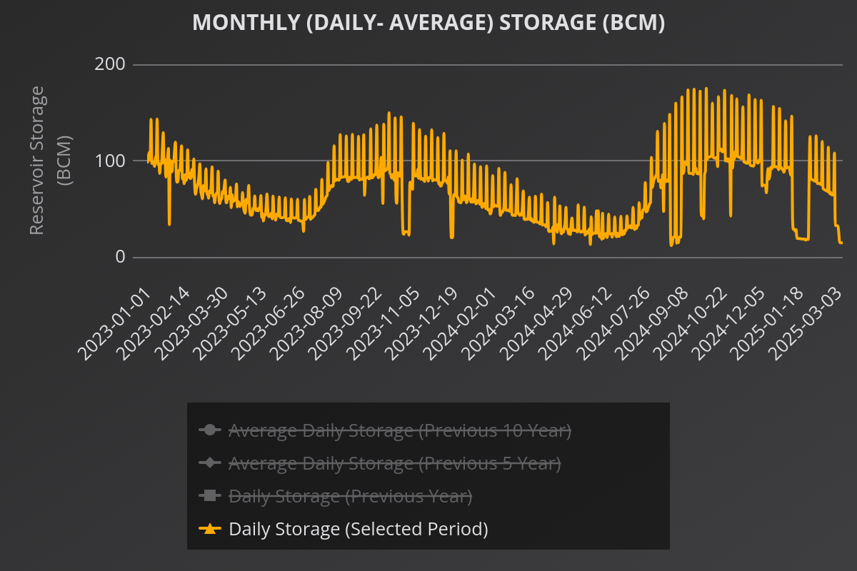

Challenges Identified
- Water Deficiency – The data confirms that the available water quantity is insufficient to meet daily consumption needs.
- Unregulated Usage – Users are often unaware of the exact volume they receive and consume, leading to inefficient utilization.
- Seasonal Shortages – The drop in water availability during summer months necessitates better water management planning.
- Need for Technological Intervention – Lack of real-time monitoring systems makes it difficult to track water usage patterns and optimize supply.
Proposed Solution: AquaSense-X
To address these challenges, we propose the development of AquaSense-X, an advanced water monitoring system designed to optimize water usage. The system will:
- Monitor Input & Consumption: Track the quantity of water received and its distribution across different usage points.
- Online Dashboard: Provide real-time water statistics to users, enabling informed decision-making.
- Usage Suggestions: Analyze consumption trends and suggest ways to optimize water usage effectively and efficiently.
- Leakage Detection: Identify discrepancies between input and output to detect wastage.
- Automated Alerts: Notify users when water levels are critically low, allowing them to plan usage accordingly.
Conclusion
The data-driven insights from our study emphasize the need for proactive water management strategies. AquaSense-X will serve as a vital tool in bridging the gap between water supply and demand by empowering users with real-time data and smart recommendations. By implementing this system, we aim to improve water conservation efforts, ensuring a sustainable and efficient water supply

